941-23 guruh talabasi Alimboyev
Jayxunning Mobil ilovalarni
ishlab chiqish fanidan
bajargan 7-amaliyot ishi

Mobil ilovalarda ma’lumotlar bazasi bilan ishlash va foydalanuvchi interfeysini ishlab chiqish (CRUD amallari va OOP asosida)
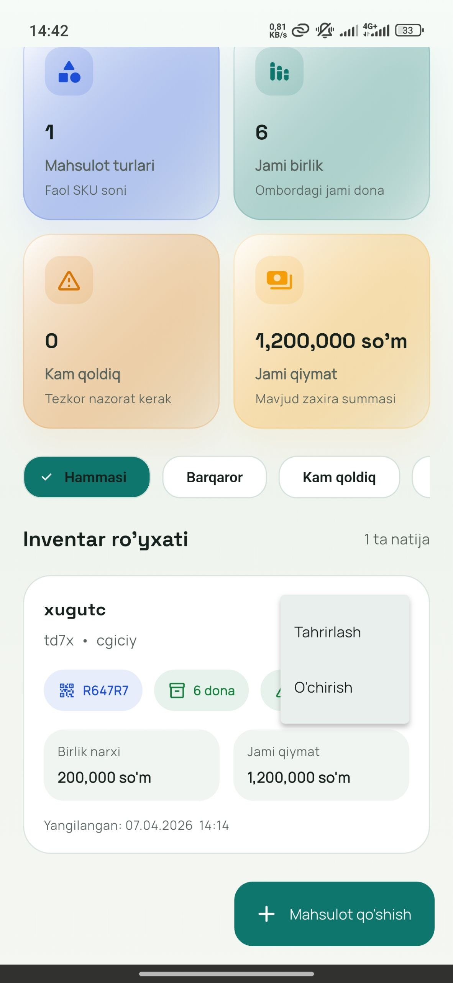
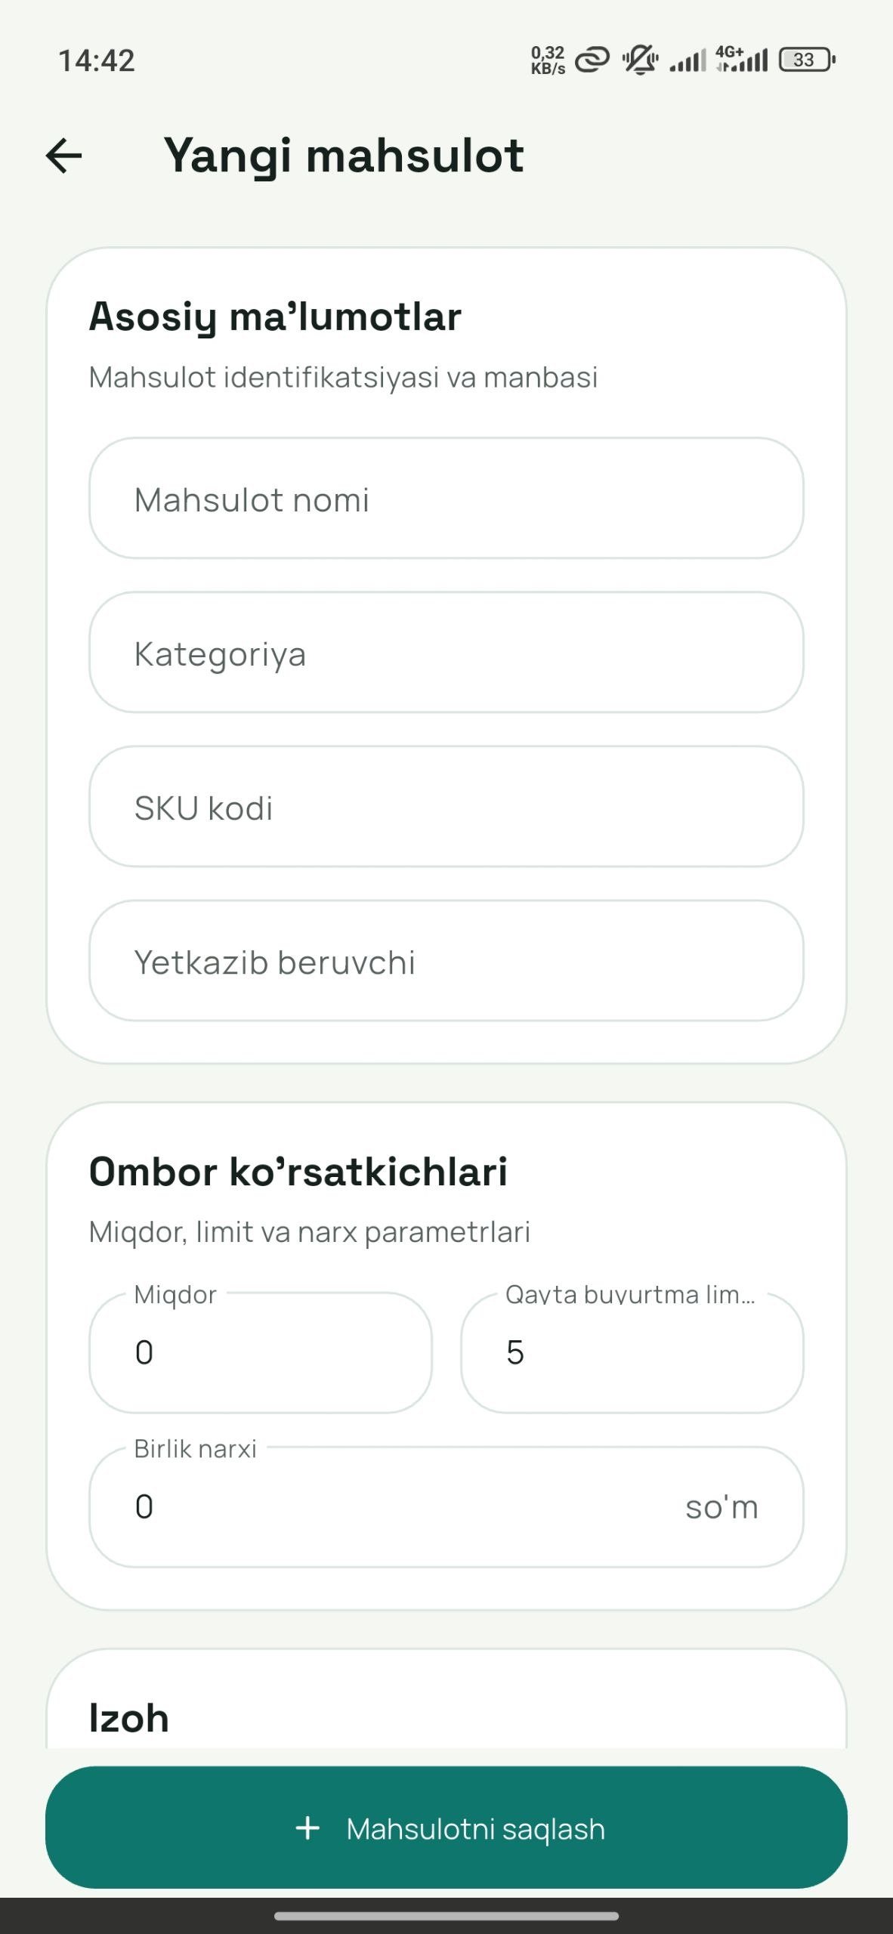
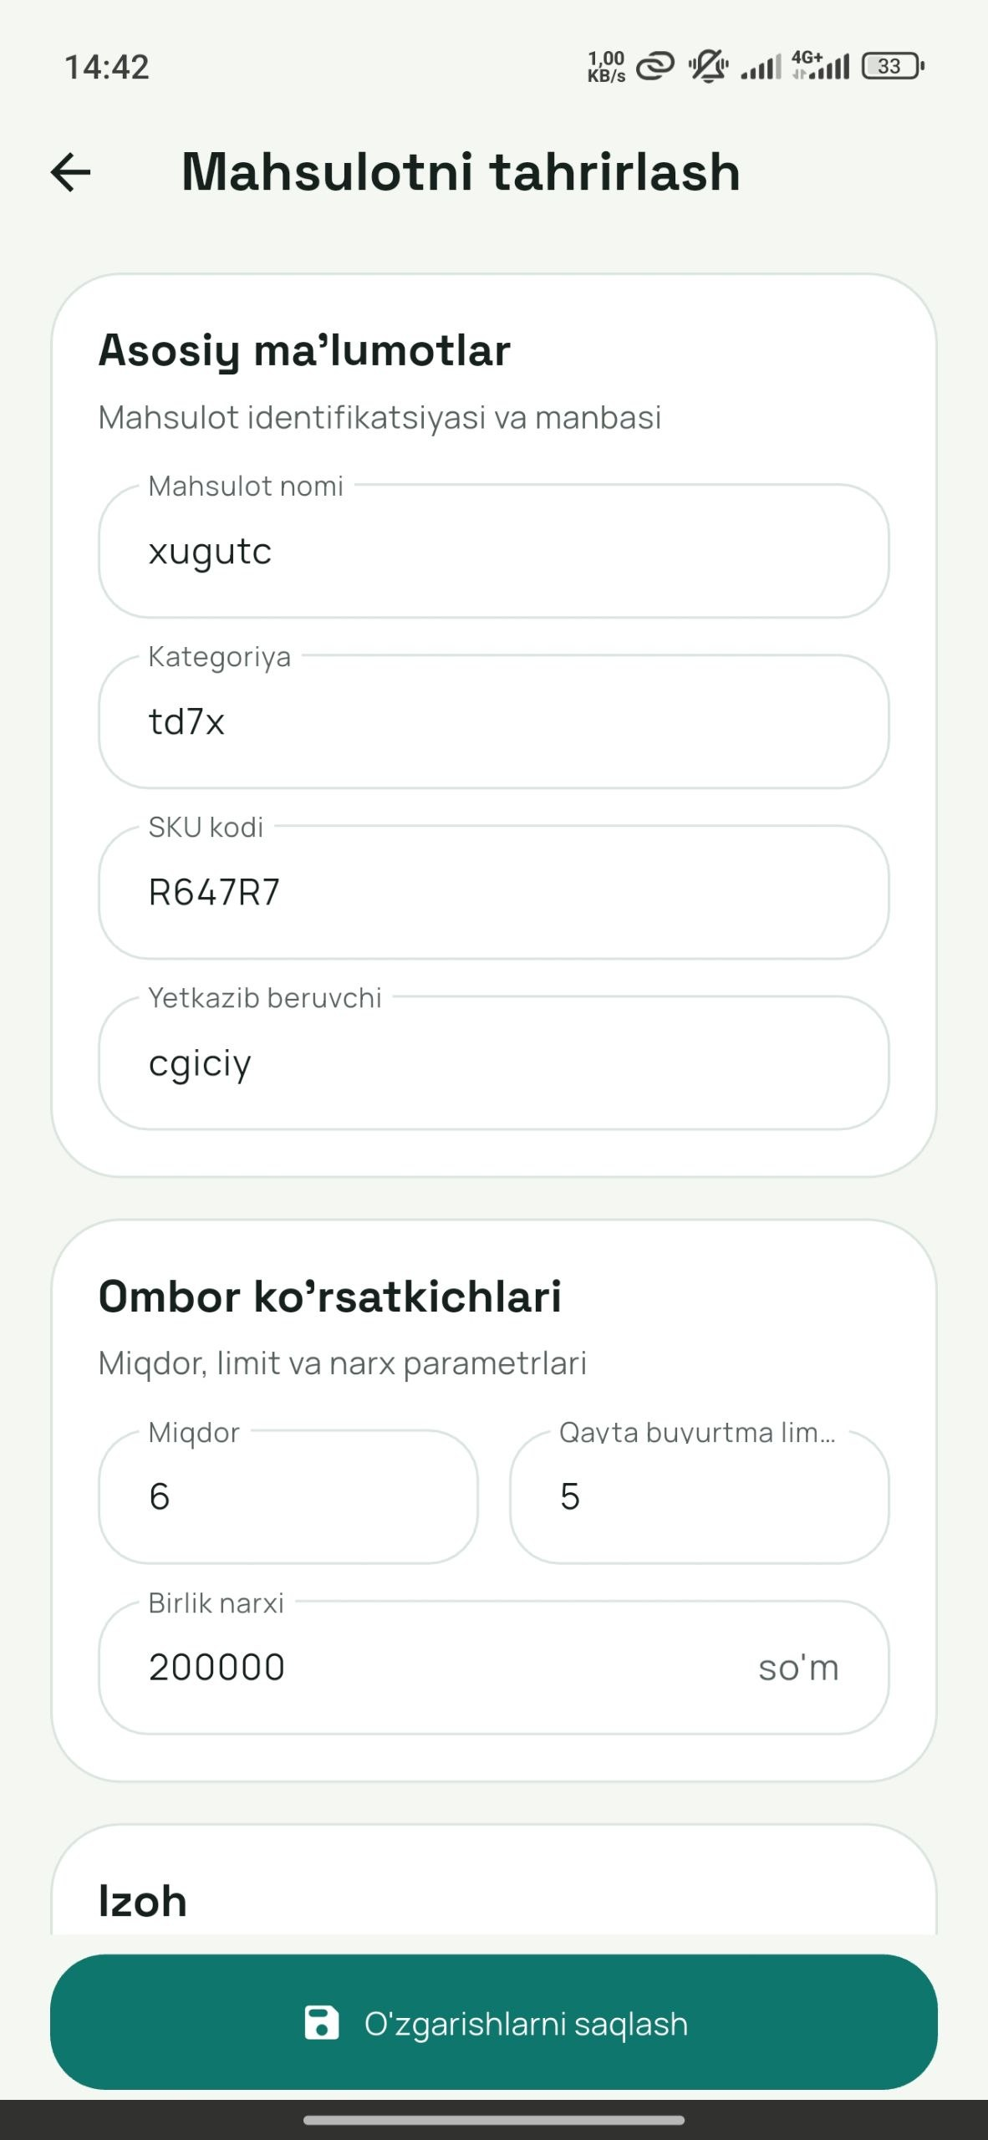
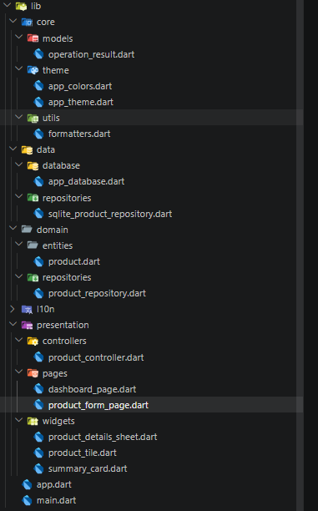
import 'package:path/path.dart' as path;
import 'package:sqflite/sqflite.dart';

class AppDatabase {
AppDatabase._();

static final AppDatabase instance = AppDatabase._();

static const String databaseName = 'ombor_pro.db';
static const int databaseVersion = 1;
static const String tableProducts = 'products';

Database? _database;

Future<Database> get database async {
return _database ??= await _open();
}

Future<Database> _open() async {
final basePath = await getDatabasesPath();
final databasePath = path.join(basePath, databaseName);

return openDatabase(
databasePath,
version: databaseVersion,
onConfigure: _onConfigure,
onCreate: _onCreate,
);
}

Future<void> _onConfigure(Database db) async {
await db.execute('PRAGMA foreign_keys = ON');
}

Future<void> _onCreate(Database db, int version) async {
await db.execute('''
CREATE TABLE $tableProducts (
id INTEGER PRIMARY KEY AUTOINCREMENT,
name TEXT NOT NULL,
category TEXT NOT NULL,
sku TEXT NOT NULL COLLATE NOCASE UNIQUE,
quantity INTEGER NOT NULL CHECK (quantity >= 0),
unit_price REAL NOT NULL CHECK (unit_price >= 0),
reorder_level INTEGER NOT NULL CHECK (reorder_level >= 0),
supplier TEXT NOT NULL,
notes TEXT NOT NULL DEFAULT '',
created_at TEXT NOT NULL,
updated_at TEXT NOT NULL
)
''');

await db.execute('CREATE INDEX idx_products_name ON $tableProducts (name)');
await db.execute(
'CREATE INDEX idx_products_category ON $tableProducts (category)',
);
await db.execute(
'CREATE INDEX idx_products_updated_at ON $tableProducts (updated_at)',
);
}

Future<void> close() async {
if (_database == null) {
return;
}
await _database!.close();
_database = null;
}
}

Widgetlar
@override
Widget build(BuildContext context) {
return Container(
padding: const EdgeInsets.all(18),
decoration: BoxDecoration(
color: Colors.white,
borderRadius: BorderRadius.circular(28),
border: Border.all(color: const Color(0xFFDCE6E1)),
),
child: Column(
crossAxisAlignment: CrossAxisAlignment.start,
children: <Widget>[
Text(title, style: Theme.of(context).textTheme.titleLarge),
const SizedBox(height: 6),
Text(
subtitle,
style: Theme.of(
context,
).textTheme.bodyMedium?.copyWith(color: AppColors.textSoft),
),
const SizedBox(height: 18),
child,
],
),
);
}

